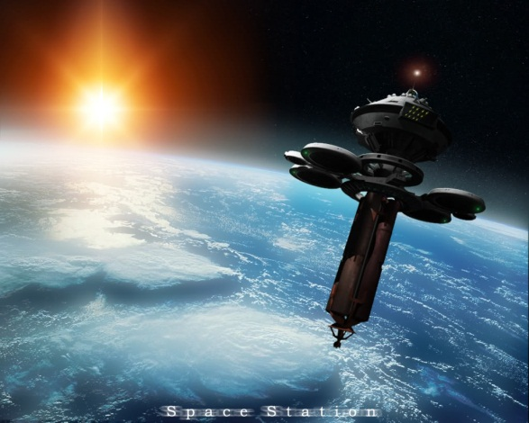
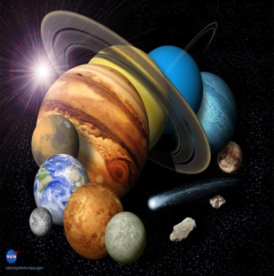
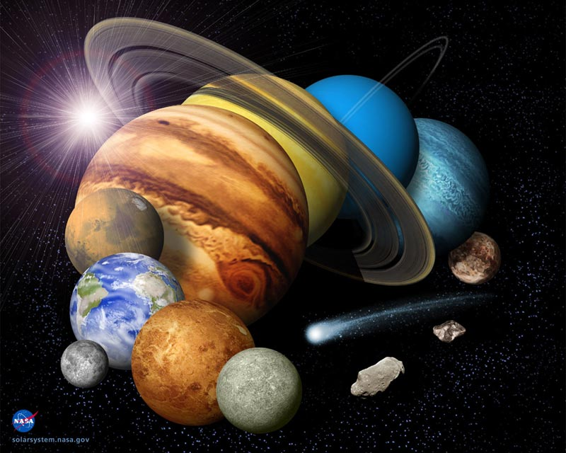

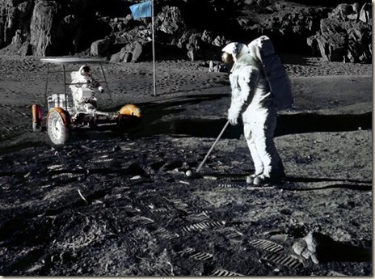
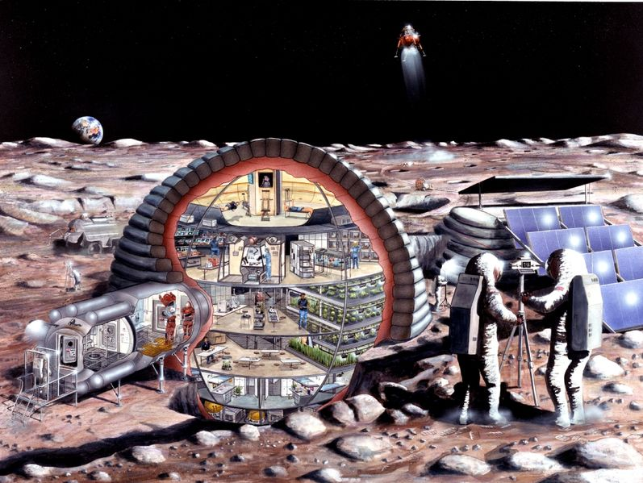
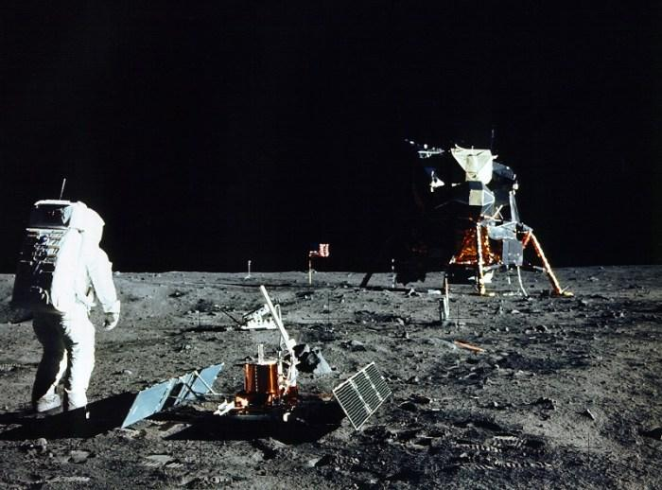
Intergalactic Travel Agency
Solar System Street
Galaxy, IL 60906
Phone (425) 555 0125
Fax (425) 555 0145

http://intergalactictravelagency.yolasite.com/

Intergalactic travel agency
Our mission is to provide you with the most comprehensive and complete planning and travel services so that you can have the adventure of a lifetime that is exciting, comfortable, and worry-free.
We look forward to showing you the solar sytem!

Intergalactic Travel Agency
Solar System Street
Galaxy, IL 60906
Phone (425) 555 0125
Fax (425) 555 0145
http://intergalactictravelagency.yolasite.com/

Intergalactic Travel Agency

Memories to last a lifetime
How often have you said out loud, “I would love to walk on the moon someday…” or “My dream in life is to see Jupiter”?
Now you can stop talking about it and do it! Stop gazing into the night sky at places you want to visit and go there! See the places you’ve only dreamed about or have seen in pictures. We make it easy to have your travel dreams come true, with expert planning and the best resources in the solar system! Yes, now you can travel worry-free and have the adventure of a lifetime!
The universe at your fingertips
Phone: (425) 555 0125

Tour packages

Pick a package
We have several packages to accommodate almost any need, or you can let us create a custom travel package for you.
Following is a sampling of some of our moon packages. Call us to find out more about these and other packages, or let us know where you want to go and we can create just the right custom package for you!

Lunar Legacy
Travel with us to the land where humanity took the first giant leap into space! Our specialists will share with you their extensive knowledge of the Moon’s history and artifacts from early Apollo missions as you visit sites like The Sea of Tranquility, the Ocean of Storms, and the Fra Mauro formation.
Rooms come fully furnished with decorative living space, as well as full 24-hour room service. We also provide the full complement of 2,000 TV channels and full internet access.
Packages range from 7 days and nights to 21 days and nights, and all packages include hotel, tours, and meals. Prices start at $30,000 per person.

The Moon
The moon is the only natural satellite of Earth and approximately ¼ of the Earth’s diameter. It is made mostly of silica, iron, and aluminum. The moon will make a complete orbit around Earth every 27.3 days.
Though the moon has a gravitational field, it is smaller than the Earth’s. If you weighed 100 lbs. on Earth, you would only weigh 16.6 lbs. on the moon!

Moon Mayhem
Need a relaxing time away. Consider the Moon Mayhem package. Here you will have all of your comforts and needs met with our full 24/7 staff meeting your every need.
Take a lunar buggy ride through the South Pole-Aiken basin, the largest crater in the solar system. And after your buggy ride you’ll be ready to explore the dark side of the moon with your team of explorers where it is believed an alien vessel may have crashed years ago
Finally take some time to relax and play our 36 whole lunar golf course. Hit the links on the same site where Allen Shepard hit the first golf balls into outer space. Balls come and buggies come with MPF systems (Moon position finder) as well as hydration unites. Meals are provided on the 12th and 22nd holes.
All of your expenses, including transportation from New York launch pad, are included in this incredible package, priced from $80,000 per person.

